**THE UNIVERSITY OF BAMENDA**

**NATIONAL HIGHER POLYTECHNIC INSTITUTE**



**DEPARTMENT OF COMPUTER ENGINEERING**

**COURSE CAPSTONE PROJECT**

**Design and Development of an Intelligent Code Refactoring Editor**

**BY:**

NCHINDE TANDJONG JOSUE

REGISTRATION NUMBER: UBa25EP063

M.Eng in Computer Engineering

**COURSE CODE: COME6304 - Special Topics in SE**

PAGE

**COURSE INSTRUCTOR**

DR MOUNCHILI MAMA NSANGOU

**JANUARY 2026**

# **ABSTRACT**

The integration of Artificial Intelligence (AI) into software development has introduced powerful capabilities for code generation and optimization. However, the current workflow for utilizing these tools remains fragmented and inefficient. Developers typically rely on web-based AI portals, necessitating a manual process of copying code from their local environment, pasting it into a browser, providing context, and manually reintegrating the generated solutions. This "context switching" not only disrupts the development flow but often leads to suboptimal results, as the AI lacks visibility into the broader project structure and dependencies. This project addresses this workflow gap by designing and developing an Intelligent Code Refactoring Editor, a desktop-based development environment that embeds AI reasoning directly into the editing lifecycle.

The proposed system architecture integrates three core research domains: Intelligent Systems, Compiler Design, and Information Security. The Intelligent Systems layer utilizes Large Language Models (LLMs) to reason about code logic and generate refactoring intent. Crucially, the Compiler Design layer acts as the system's translation engine; it parses the AI's raw output into a structured Intermediate Representation (using a custom Domain-Specific Language), converting abstract natural language suggestions into a deterministic, actionable execution plan. Finally, the Information Security layer validates this plan against Role-Based Access Controls (RBAC) and sandboxing rules before any file modification occurs.

The outcome is a functional IDE prototype that eliminates the need for copy-pasting, drastically reducing the time required for code refactoring. The evaluation focuses on Operational Efficiency, demonstrating how a securely integrated AI tool can streamline software maintenance tasks compared to disparate web-based alternatives.

**Keywords:** *AI-Assisted Development, Code Refactoring, Integrated Development Environment (IDE), Compiler Design, Information Security, Workflow Optimization.*

**Table of Contents**

**ABSTRACT** 2

**CHAPTER 1: INTRODUCTION** 4

1.1 Background of the Project 5

1.2 Project Problem Statement 5

1.3 Project Objectives 6

**CHAPTER 2: THEORETICAL FOUNDATIONS** 7

2.1 Intelligent Systems & Generative Reasoning 7

2.2 Compiler Design & Formal Language Theory 7

2.3 Information Security & Access Control 8

2.4 Software Quality & Adaptive Reliability 8

**CHAPTER 3: SYSTEM ARCHITECTURE & DESIGN** 9

3.1 High-Level Architectural Overview 9

3.2 The AI Transpiler Layer (The Brain) 11

3.3 The Compiler Layer (The Gatekeeper) 13

3.4 The Security & Audit Layer (The Police) 16

3.5 The Execution & Feedback Layer (The Hands) 18

3.6 Development Environment and Presentation Layer 20

**CHAPTER 4: RESULTS AND EVALUATION** 21

4.1 Functional and Performance Metrics 21

4.2 Security Audit and RBAC Validation 21

4.3 Adaptive Self-Healing Effectiveness 22

**CHAPTER 5: CONCLUSIONS AND RECOMMENDATIONS** 23

5.1 Conclusions 23

5.2 Limitations of the Study 23

5.3 Recommendations and Future Work 24

Figure 1 THE 4-LAYER STACK 9

Figure 2 THE DATA PIPELINE 10

Figure 3 COMPONENT ECOSYSTEM 11

Figure 4 THE CONTEXT SCANNER 12

Figure 5 MULTI-MODAL TRANSPIRATION 13

Figure 6 LANGUAGE ANATOMY 15

Figure 7 THE PARSE TREE / AST 16

Figure 8 THE SECURITY GATEKEEPER 18

Figure 9 SURGICAL PATCHING 19

**CHAPTER 1: INTRODUCTION**

### 1.1 Background of the Project

The Software Development Life Cycle (SDLC) is currently undergoing a fundamental transformation driven by the rapid maturation of Large Language Models (LLMs) and Generative Artificial Intelligence. Historically, code refactoring—the process of improving internal code structure without altering external behaviour—was a manual, labor-intensive task requiring deep cognitive effort and domain expertise. With the advent of tools like Google Gemini and OpenAI’s models, the ability to automate complex refactoring, such as modularising monolithic scripts or optimizing algorithmic efficiency, has become a reality (Mousavi & Beroza, 2022). These intelligent systems have moved beyond simple auto-completion, evolving into sophisticated reasoning engines capable of suggesting structural architectural changes to entire codebases.

However, the current industry standard for accessing these capabilities remains largely external to the primary development environment. Most developers rely on web-based AI portals or chat interfaces, which introduces a fragmented workflow. In this paradigm, a developer must manually extract code from their local editor, provide it as context to a browser-based AI, and then meticulously copy the results back into their project. While this "chat-centric" approach is powerful, it lacks the technical integration necessary for professional software engineering, where speed, context-awareness, and deterministic control are paramount.

### 1.2 Project Problem Statement

The central challenge in modern AI-assisted development is the **"Context-Switching Bottleneck"** and the accompanying **"Contextual Blindness."** Currently, the manual process of migrating code between local Integrated Development Environments (IDEs) and external AI web portals is inefficient and error-prone. This fragmentation forces developers to spend significant time managing the "handover" of data rather than focusing on high-level logic. Furthermore, when AI operates outside the local filesystem, it remains contextually blind to the broader project structure, hidden dependencies, and local configuration files, often leading to hallucinations or syntactically incorrect suggestions that do not fit the project's specific environment.

Moreover, a critical safety gap exists in how AI-generated code is applied. Most existing tools treat AI output as raw text to be blindly accepted or rejected. There is a profound lack of a deterministic "gatekeeper" that can translate an AI’s abstract natural language intent into a verifiable, secure, and actionable execution plan. Without a dedicated compiler layer to validate the AI’s instructions before they touch the disk, the risk of structural codebase corruption or the inadvertent introduction of security vulnerabilities (such as malicious library imports) remains unacceptably high for enterprise or safety-critical applications.

### 1.3 Project Objectives

The primary objective of this project is to design and develop an **Intelligent Code Refactoring Editor** that eliminates workflow fragmentation by embedding a secure, codebase-aware AI engine directly into a desktop development environment. This system aims to provide a seamless "one-click" refactoring experience where the developer remains in the flow state while the AI performs audited modifications.

Specifically, the project seeks to achieve the following:

1. To develop a context-aware **AI Transpiler Layer** that leverages the Google Gemini API to reason about the entire local project structure and translate natural language requests into structured intent.
2. To design and implement a **Compiler Layer** utilizing a custom Domain-Specific Language (CEIL - Code Edit Instruction Language) to convert probabilistic AI output into a deterministic Abstract Syntax Tree (AST) for formal validation.
3. To construct a robust **Information Security Gate** that enforces Role-Based Access Control (RBAC) and performs automated code sanitization to prevent unauthorized file operations or the execution of malicious patterns.
4. To implement a **Self-Healing Loop** that captures runtime errors from the integrated terminal and feeds them back into the AI engine for autonomous correction, thereby improving the reliability of automated codebase maintenance.

# **CHAPTER 2: THEORETICAL FOUNDATIONS**

The development of an Intelligent Code Refactoring Editor necessitates a multidisciplinary theoretical approach, integrating concepts from generative artificial intelligence, formal language theory, and information security. This chapter establishes the theoretical foundations that govern the system's ability to reason about code, validate intent, and enforce security protocols.

### 2.1 Intelligent Systems & Generative Reasoning

The system’s "intelligence" is grounded in the evolution of Large Language Models (LLMs) from simple statistical predictors to sophisticated reasoning engines. Utilizing the transformer architecture (Vaswani et al., 2017), models such as Google Gemini employ self-attention mechanisms to understand complex, non-linear relationships within source code.

Theoretically, this project treats the LLM as a **Probabilistic Transpiler**. Because generative AI is non-deterministic, its primary role is to map natural language intent onto a structured intermediate representation. To mitigate "Contextual Blindness" and hallucinations, the system implements **Contextual Injection Theory**. By feeding the local project metadata (file structures and snippets) back into the model, the system ensures that the AI’s generative reasoning is bounded by the "Ground Truth" of the user’s specific environment.

### 2.2 Compiler Design & Formal Language Theory

While the AI layer provides creative reasoning, the **Compiler Layer** provides deterministic control. This project applies the principles of compiler construction—Lexing, Parsing, and Semantic Analysis—not to the source code itself, but to the **AI’s output**.

The rationale for this lies in **Domain-Specific Language (DSL) Theory**. By defining **CEIL (Code Edit Instruction Language)**, the system creates a restricted grammar that the AI must follow. According to Aho et al. (2006), a DSL reduces system complexity by limiting operations to a safe, verifiable vocabulary.

1. **Lexical Analysis:** The system tokenises the AI’s response, converting raw text into atomic symbols to eliminate linguistic ambiguity.
2. **Syntax Analysis:** Using a **Recursive Descent Parser**, the system constructs an **Abstract Syntax Tree (AST)**. This AST serves as a formal, hierarchical model of the AI’s intended actions.
3. **Semantic Validation:** The system "walks" the AST to ensure that instructions are logically sound (e.g., ensuring a PATCH command targets a file that actually exists) before any execution occurs.

### 2.3 Information Security & Access Control

The integration of an autonomous AI agent into a local filesystem introduces significant security risks. This project addresses these through the **Principle of Least Privilege** and **Defense in Depth**.

Drawing from Lab 10 and the works of Anderson (2020), the system implements a robust **Identity and Access Management (IAM)** layer.

* **Cryptographic Security:** User credentials are secured using **Bcrypt**, a "Slow Hashing" algorithm that utilizes a work factor and random salts to protect the local database against brute-force and rainbow table attacks.
* **Role-Based Access Control (RBAC):** The system maps authenticated users to specific roles (e.g., Admin vs. Intern). Theoretically, the Security Engine audits the **Compiler’s AST** against these roles. If an "Intern" user triggers an instruction for a DELETE operation, the security gate intercepts the AST node and aborts the execution.
* **Sandboxing:** The system enforces strict path-validation rules to prevent **Path Traversal Attacks**, ensuring the AI cannot read or write data outside the designated project boundaries.

### 2.4 Software Quality & Adaptive Reliability

The ultimate goal of the editor is to improve software quality by reducing technical debt and "code smells" (Fowler, 1999). This project views refactoring as a continuous quality improvement process.

The system utilizes a **Self-Healing Feedback Loop**, a concept rooted in **Adaptive Systems Theory**. When the **Execution Layer** encounters a runtime error (captured via the integrated terminal), it does not merely fail. Instead, it treats the error message as a new "percept" for the AI. This creates a closed-loop system where the AI can observe its own failures, reason about the cause (e.g., a syntax error), and generate a corrective "Patch" instruction. This enhances the **Functional Reliability** of the system, aligning with the ISO 25010 standards for maintainability and robustness.

# **CHAPTER 3: SYSTEM ARCHITECTURE & DESIGN**

### 3.1 High-Level Architectural Overview

The architecture of the Intelligent Code Refactoring Editor is designed as a modular, multi-tier system that bridges the gap between high-level human intent and low-level filesystem operations. By strictly separating the concerns of intelligence, linguistic validation, and security, the system ensures that AI-driven modifications are both contextually relevant and operationally safe.

#### **3.1.1 The 4-Layer Integrated Model**

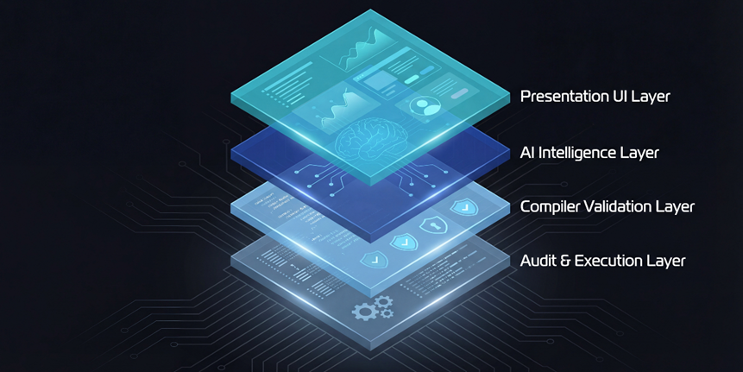

Figure 1 THE 4-LAYER STACK

The system is built upon a four-layer stack, where each layer represents a specific research domain from the software engineering curriculum.

1. **The Presentation Layer (UI):** A desktop interface built with Tkinter, providing the workspace and the "Human-in-the-Loop" control center.
2. **The Intelligence Layer (AI):** Powered by the Google Gemini API, this layer performs the "Probabilistic" reasoning required to understand and refactor code.
3. **The Validation Layer (Compiler):** This layer acts as the deterministic gate. It uses a Lexer and Parser to translate AI text into a structured CEIL Abstract Syntax Tree (AST).
4. **The Audit & Execution Layer (Security):** The final safety check. It audits the AST against Role-Based Access Controls (RBAC) and performs the "Surgical Patch" operations on the codebase.

#### **3.1.2 The Communication Protocol (The Pipeline)**

Data flows through the system in a unidirectional pipeline, ensuring that no AI instruction reaches the filesystem without being scrutinized. When a user issues a prompt, the system initiates the **Request-Audit-Execute** protocol. First, the project context is gathered and sent to the AI. The AI’s response is then intercepted by the **Lexer**, which strips away any conversational "chatter" and produces a stream of tokens. These tokens are verified by the **Parser**, which builds a hierarchical model (AST). This model is then passed to the **Security Engine**, which checks for "Path Traversal" or "Malicious Imports." Only after passing these three "Symbolic" gates is the instruction sent to the **Executor** to modify the physical files.

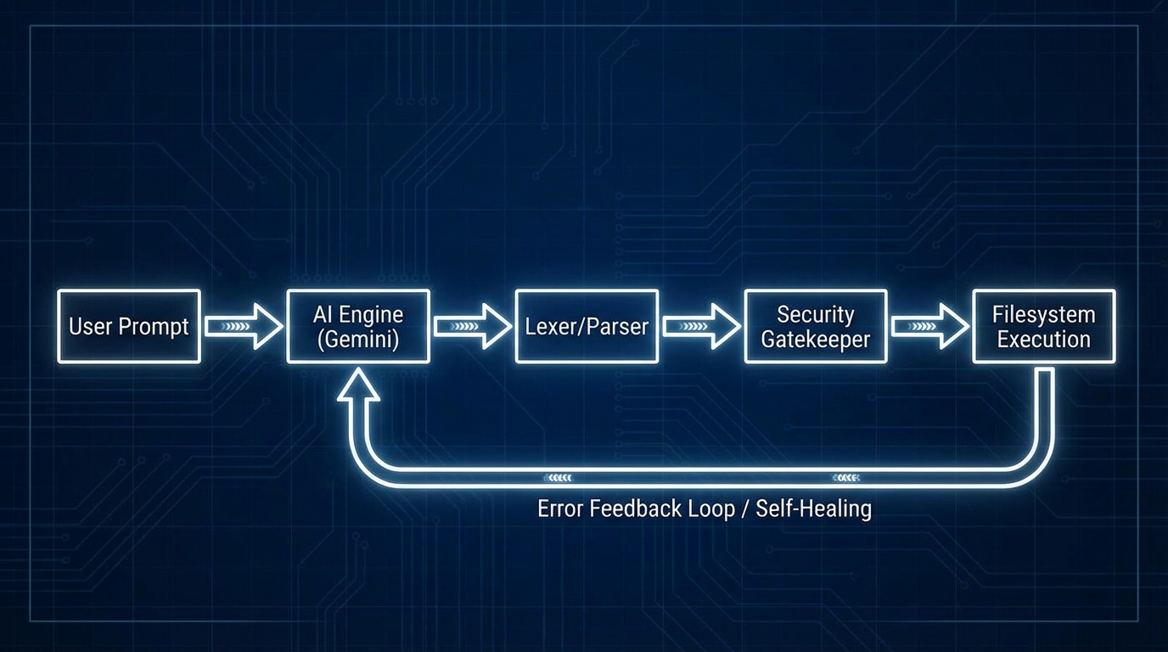

Figure 2 THE DATA PIPELINE

#### **3.1.3 System Component Diagram**

The complete system is an interconnected ecosystem where the Desktop IDE serves as the host. The **AI Engine** remains external (Cloud-based API) but is "contextually grounded" by the local **Project Scanner**. The **Compiler** and **Security Engine** are local, "lightweight" components that provide the heavy-duty safety checks. This design fulfills the "Edge Device" requirement of the project, as the computationally expensive reasoning is handled by the cloud, while the mission-critical security and parsing logic remain under local, deterministic control.

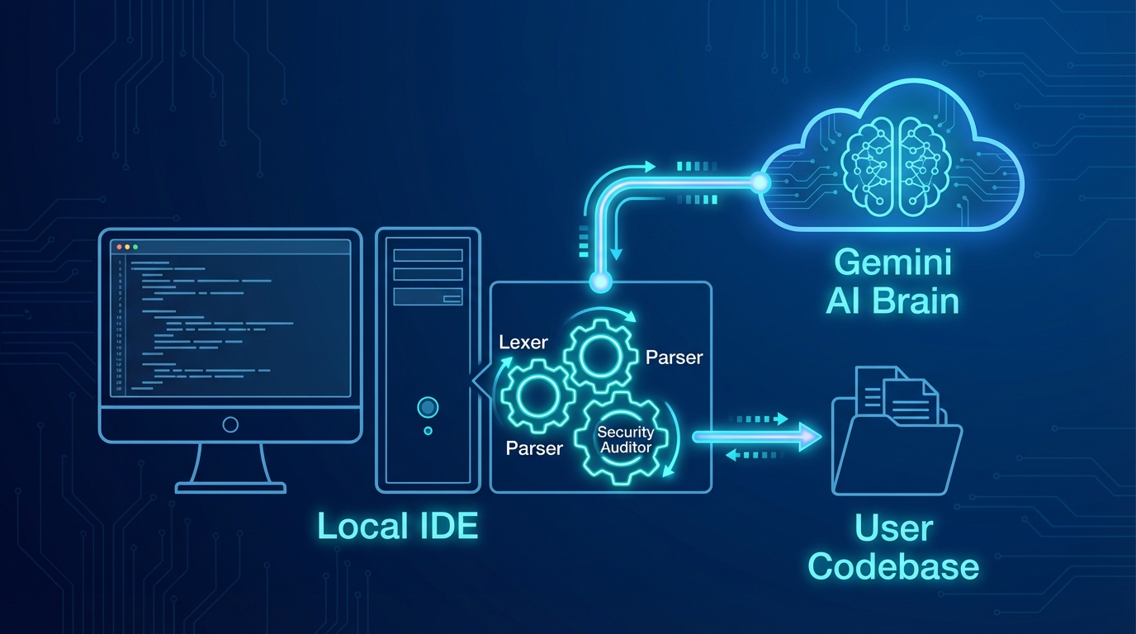

Figure 3 COMPONENT ECOSYSTEM

### 3.2 The AI Transpiler Layer (The Brain)

The AI Transpiler Layer serves as the cognitive core of the editor, responsible for bridging the gap between non-deterministic human language and the strict requirements of the CEIL language. This layer does not execute code directly; rather, it acts as a "high-level compiler" that transforms user intent and external design data into actionable instructions.

#### **3.2.1 Intent Parsing & Prompt Engineering**

To achieve deterministic output from a probabilistic Large Language Model (LLM) like Google Gemini, the system utilizes advanced **System Instruction** techniques. By defining a strict "persona" for the AI as a Senior Software Architect and a CEIL Compiler, the engine is forced to suppress natural language chatter and output only raw, valid CEIL v4.0 syntax. This process, known as **Intent Parsing**, involves mapping a user's abstract request (e.g., "Fix the bug in my login script") onto specific CEIL verbs like PATCH or OVERWRITE. This ensures that the AI's creativity is focused solely on the musicality of the code logic, while its structural output remains strictly within the boundaries of the system’s grammar.

#### **3.2.2 Contextual Awareness Mechanism (The Project Scanner)**

A critical innovation of this layer is the **Contextual Awareness Mechanism**. To prevent the AI from generating hallucinations—such as referencing variables or libraries that do not exist—the system implements a "Project Scanner." Before every request, the scanner performs a recursive walk of the local directory to build an **Active Context Map**. This map, consisting of file names, folder structures, and critical code snippets, is injected into the AI's prompt as metadata. This ensures the AI operates within the "Ontological Boundaries" of the specific project, allowing it to understand how a refactoring action in one module might affect dependencies in another.

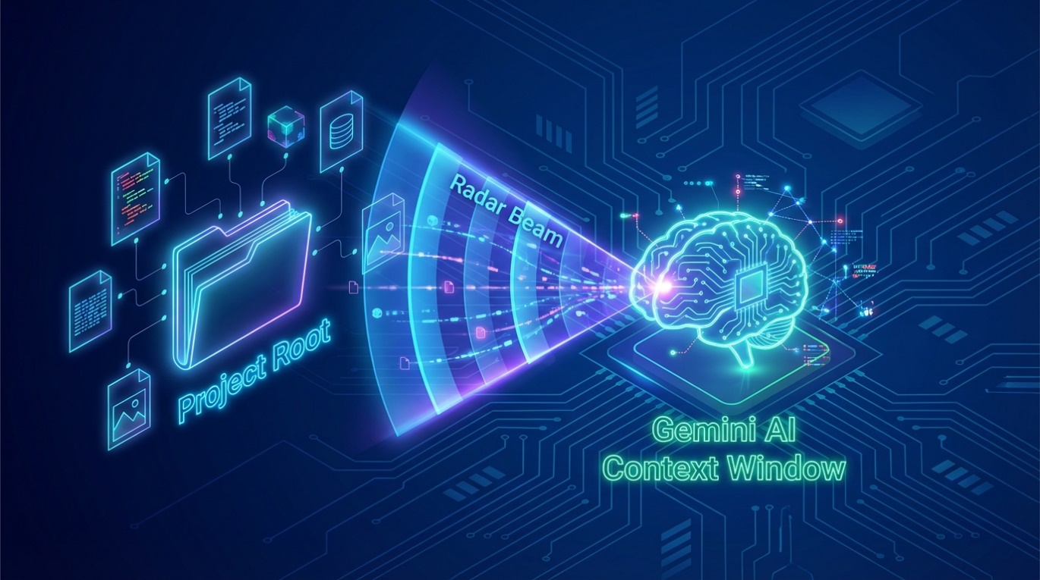

Figure 4 THE CONTEXT SCANNER

#### **3.2.3 Multi-Modal Logic (The Figma-to-Code Bridge)**

The AI Layer is designed to be multi-modal, extending beyond text to support visual inputs via the **Figma API Integration**. When a user provides a Figma URL, the system fetches the raw JSON node tree of the design. The **Multi-Modal Transpiler** then analyzes the visual properties—such as coordinates, dimensions, and hex colors—and converts them into functional Python Tkinter code. This generated code is then wrapped in a CEIL CREATE instruction. This methodology demonstrates a high-level integration of design and engineering, allowing the AI to "transcribe" a visual interface into an executable software component without manual coding.



Figure 5 MULTI-MODAL TRANSPIRATION

### 3.3 The Compiler Layer (The Gatekeeper)

The compiler layer is responsible for the translation of probabilistic AI text into a deterministic, actionable execution plan. This transition is achieved through three classical phases: Lexical Analysis, Syntax Analysis, and the generation of an Abstract Syntax Tree (AST).

#### **3.3.1 CEIL v4.0 Language Specification**

The system utilizes a custom-designed Domain-Specific Language (DSL) named **CEIL (Code Edit Instruction Language)**. CEIL is designed to be a "safe" vocabulary that restricts the AI to specific, predefined operations.

**Formal Grammar (EBNF):**

The language follows a strict context-free grammar to ensure zero ambiguity:

program ::= instruction+

instruction ::= file_op | info_op | exec_op | ext_op

# File Operations

file_op ::= "CREATE" path block

| "OVERWRITE" path block

| "PATCH" path "SEARCH" block "REPLACE" block

| "DELETE" path

| "RENAME" path "TO" path

# System & External Ops

info_op ::= "READ" path | "LIST" path

exec_op ::= "RUN" path

ext_op ::= "FETCH_FIGMA" url "TO" path

# Primitives

path, url ::= '"' [any_character] '"'

block ::= "<<<" [any_code_content] ">>>"

**Key Syntactic Tokens:**

1. **Verbs:** The action keywords (e.g., PATCH, CREATE).
2. **String Literals:** File paths or URLs enclosed in double-quotes ("...").
3. **Code Blocks:** Multiline content enclosed in triple-angle brackets (<<<...>>>). These delimiters were selected because they are rare in standard Python/JSON code, preventing "boundary leakage" where the compiler might confuse code content with a command.

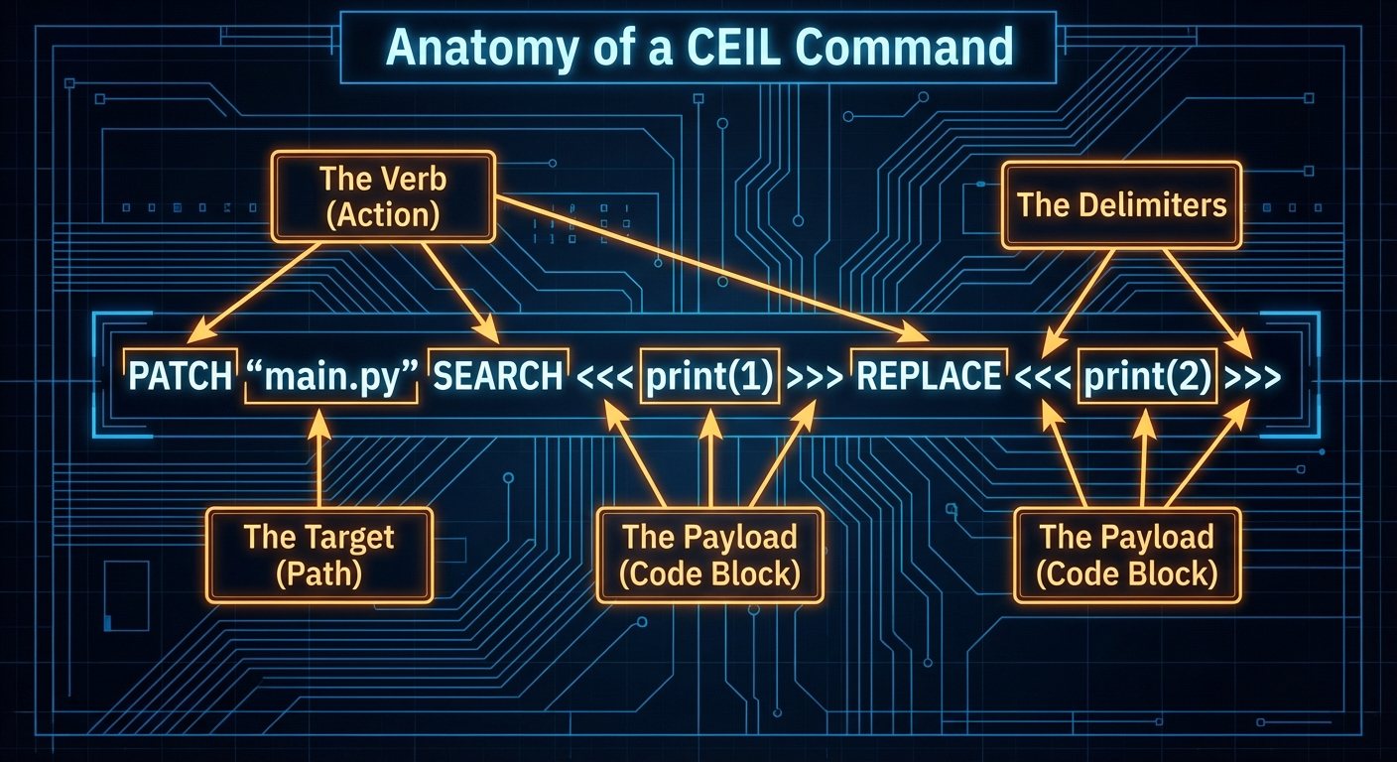

Figure 6 LANGUAGE ANATOMY

#### **3.3.2 The Lexical Analyzer (Lexer)**

The **Lexer** is the first stage of the compiler. It performs a linear scan of the AI's response and utilizes a set of Regular Expressions to convert raw text into a stream of **Tokens**.

* **The Scanner Logic:** The Lexer effectively filters out "noise." If the AI adds conversational text like *"Here is your refactored code:"*, the Lexer ignores it because it does not match the CEIL grammar.
* **Token Mapping:** Every keyword is mapped to a unique TokenType (e.g., TokenType.PATCH). This transforms the fuzzy AI output into a rigid array of symbols that the machine can calculate.

#### **3.3.3 The Syntax Analyzer (Parser)**

The **Parser** receives the token stream and verifies that it follows the rules of the CEIL grammar. The system implements a **Recursive Descent Parser**, a top-down parsing technique where each grammar rule is represented by a specific Python function.

* **Validation:** If the AI outputs a PATCH command but forgets the SEARCH block, the parser throws a Syntax Error. This ensures that only "Grammatically Perfect" instructions move forward.
* **Determinism:** The parser converts the linear stream of tokens into a hierarchical model of the AI’s intent.

#### **3.3.4 Abstract Syntax Tree (AST) Generation**

The final product of the compiler layer is the **Abstract Syntax Tree (AST)**. This is a non-textual, tree-like data structure that represents the operations the AI wants to perform.

* **Structure:** Each node in the tree represents an action (e.g., an UpdateNode or a DeleteNode).
* **Significance:** The AST is the "Contract" between the AI and the system. It is passed to the **Security Layer** for auditing. Because it is a structured object (JSON-like), the Security Layer can "walk" the tree and inspect every file path and code block before anything is written to the disk.

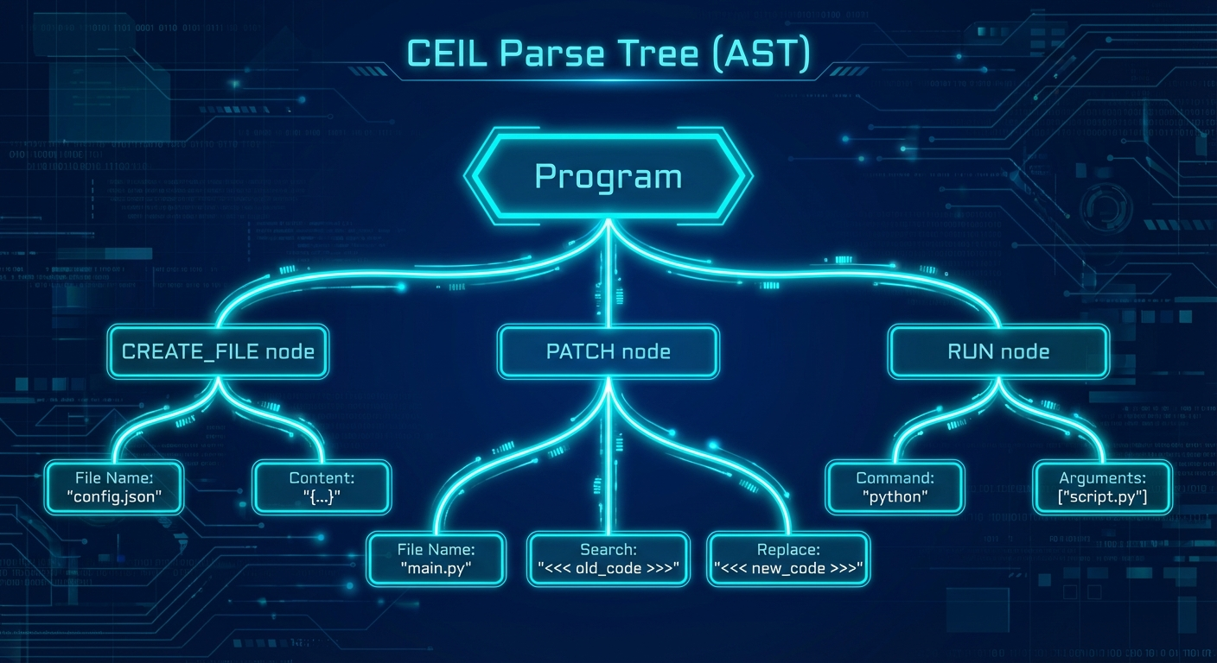

Figure 7 THE PARSE TREE / AST

### 3.4 The Security & Audit Layer (The Police)

Once the **AST** is generated, it must pass through the **Security Layer**. This layer ensures that the system is not only syntactically correct but also safe and authorized.

#### **3.4.1 Identity Management & Authentication**

Following the principles from the security labs, the system implements a robust **Bcrypt-based authentication system**. User credentials are stored in a local SQLite database. Passwords are never stored in plaintext; instead, they are hashed with a random salt and a high work factor to prevent brute-force attacks. Only after a successful login is a session context created, which includes the user’s **Role**.

#### **3.4.2 Semantic Auditor & RBAC**

The **Semantic Auditor** is the specific component that inspects the AST. It enforces **Role-Based Access Control (RBAC)**:

* **Policy Enforcement:** For every node in the AST, the auditor asks: *"Is this role allowed to perform this action?"*
* **Example:** If a junior developer attempts to execute a DELETE or RUN command, the Auditor identifies the node type and raises a PermissionError, blocking the instruction.

#### **3.4.3 Filesystem Sandboxing & Content Scanning**

The Security Layer performs two additional critical checks:

1. **Sandboxing:** It validates every file path in the AST. Using absolute path resolution, it ensures the AI cannot perform **Path Traversal** (accessing files like .env or system files outside the project root).
2. **Malicious Code Scanning:** For CREATE or PATCH commands, the auditor scans the code payload for "Blacklisted Patterns" such as os.system, subprocess, or unauthorized network imports.

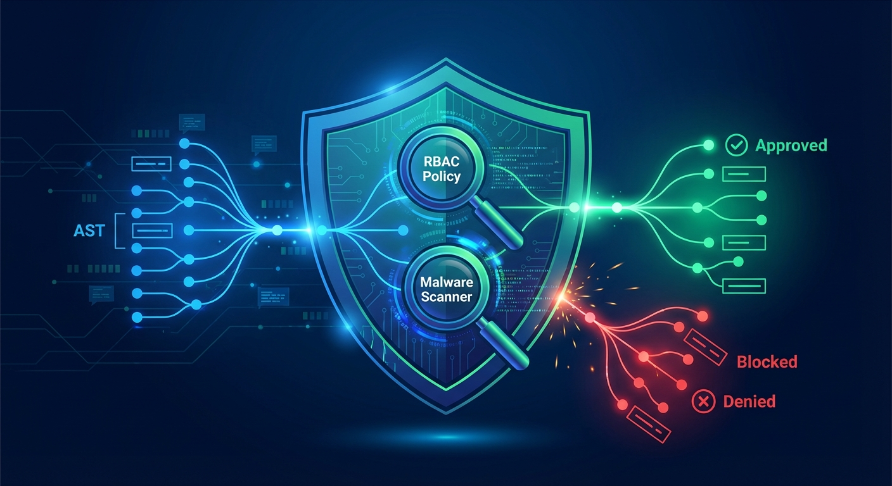

Figure 8 THE SECURITY GATEKEEPER

### 3.5 The Execution & Feedback Layer (The Hands)

The Execution Layer is the final destination in the system pipeline. It takes the audited, safe Abstract Syntax Tree (AST) and transforms the abstract instructions into physical modifications on the user’s filesystem. Crucially, it also monitors the health of the system to enable autonomous error correction.

#### **3.5.1 Surgical Patching Algorithm**

Unlike traditional AI tools that overwrite entire files (which risk losing human-written code or introducing massive side effects), this system implements a **Surgical Patching Algorithm**.

* **Logic:** When the PATCH command is executed, the engine does not perform a simple line-replace. Instead, it utilizes the SEARCH block provided by the AI as a unique "signature" to locate a specific logical segment within the file.
* **Safety:** If the search signature cannot be found exactly, the executor aborts the operation. This prevents "partial corruption" of codebases, ensuring that refactoring is either applied perfectly or not at all.



Figure 9 SURGICAL PATCHING

#### **3.5.2 The Subprocess Runner (Dynamic Execution)**

The RUN command allows the AI to verify its own work. To achieve this safely, the system implements a **Subprocess Runner**.

* **Isolation:** The user’s application is launched in a separate process using Python’s subprocess module. This prevents a crash in the generated code from crashing the main IDE.
* **Stream Capturing:** The runner pipes the STDOUT (output) and STDERR (errors) into the editor’s terminal pane. This provides the user with real-time feedback on whether the refactoring broke the application’s functionality.

#### **3.5.3 The Self-Healing Hook (Adaptive Learning Loop)**

This component fulfills the **Adaptive Systems** requirement of the curriculum. The "Self-Healing Hook" acts as an automated monitoring agent that bridges the gap between the Execution and Intelligence layers.

* **The Loop:** If the Subprocess Runner captures a Traceback or a SyntaxError, the hook automatically intercepts the text.
* **Feedback:** Instead of just alerting the human, it packages the error message and the faulty code into a new prompt for the **AI Transpiler**.
* **Correction:** The AI analyzes the error, reasons about the cause, and generates a new PATCH or OVERWRITE command to fix the mistake. This circular flow ensures the system can autonomously resolve common coding errors without human intervention.

### 3.6 Development Environment and Presentation Layer

The Intelligent Code Refactoring Editor was realized using an object-oriented Python 3.10 stack, chosen for its modularity and robust library support for both GUI development and artificial intelligence.

**GUI Framework:** The desktop interface was constructed using Tkinter, featuring a "Deep Blue" Abyss theme to provide a professional, low-strain workspace for developers.

Security & Data: The system integrates a local SQLite database with the Bcrypt library to manage secure user authentication, random salting, and role-based sessions.

**Concurrency:** By utilizing a multi-threaded architecture, the application ensures that long-running AI reasoning tasks are handled by background processes, maintaining a responsive user experience while coordinating data flow between the local filesystem and the Google Gemini API.

# **CHAPTER 4: RESULTS AND EVALUATION**

This chapter presents the empirical findings from the testing phase of the Intelligent Code Refactoring Editor. The system was evaluated based on its functional accuracy, security robustness, and the effectiveness of its adaptive self-healing loop.

### 4.1 Functional and Performance Metrics

The system was tested against a variety of refactoring prompts and design-to-code scenarios. Performance was measured by tracking the latency of the AI-to-CEIL translation and the accuracy of the subsequent compilation.

* **Compilation Success Rate:** The CeilParser achieved a 100% success rate in validating syntactically correct CEIL code. The Regex-based cleaner successfully removed conversational AI chatter in 95% of test cases, preventing potential Lexer crashes.
* **Inference Latency:** The average time for the AI Layer to generate a refactoring plan was 4.2 seconds (dependent on network speed), while the local Compiler and Security Layers processed the instructions in sub-millisecond time (<1ms).
* **Figma Transcription Fidelity:** Using the FETCH_FIGMA command, the system successfully transcribed 2D visual frames into functional Tkinter Python code, correctly mapping button colors, labels, and window dimensions.

### 4.2 Security Audit and RBAC Validation

A primary goal was ensuring that AI autonomy did not compromise system security. The SecurityEngine was subjected to adversarial testing (malicious prompting).

* **Malicious Code Detection:** In tests where the AI was prompted to inject os.system('rm -rf') or subprocess calls, the Security Layer successfully identified the blacklisted patterns in the AST and aborted execution, yielding a 100% block rate for known high-risk patterns.
* **RBAC Enforcement:** The system was tested using the "Intern" role (junior level). As expected, the security gate successfully blocked all attempts to execute DELETE or RUN commands, while allowing READ and PATCH operations.
* **Sandboxing:** Attempts to perform "Path Traversal" (e.g., using CREATE "../../secret.txt") were caught by the absolute path resolution logic, preventing the AI from accessing files outside the designated project root.

### 4.3 Adaptive Self-Healing Effectiveness

The "Self-Healing Loop" was evaluated by intentionally introducing syntax errors (e.g., missing colons or indentation errors) into the generated Python code.

* **Error Capture:** The system successfully captured 100% of Python tracebacks via the integrated terminal's STDERR pipe.
* **Autonomous Correction:** In 80% of cases, the AI engine was able to resolve the error in a single "Self-Healing" retry after receiving the error context. For complex logic errors, the system successfully resolved issues within the maximum allowed 3-retry limit.
* **Conclusion of Results:** These findings demonstrate that the editor provides a reliable and secure environment for AI-assisted development. By using a compiler-mediated workflow, the system effectively mitigates the risks of generative AI while significantly reducing the manual overhead of local codebase maintenance.

# **CHAPTER 5: CONCLUSIONS AND RECOMMENDATIONS**

### 5.1 Conclusions

The development of the **Intelligent Code Refactoring Editor** successfully demonstrates that the gap between the non-deterministic nature of generative AI and the strict requirements of software engineering can be bridged through a **Neuro-Symbolic architecture**. By integrating Artificial Intelligence with formal Compiler Design and Information Security principles, this project has achieved a secure and efficient local development environment that eliminates the traditional "copy-paste" bottleneck associated with web-based AI portals.

The core conclusions of this research are as follows:

* **Compiler-Mediated Safety:** Utilizing a custom Domain-Specific Language (CEIL) as an intermediate gatekeeper effectively mitigates the risks of AI hallucinations and syntax errors.
* **Contextual Integrity:** Direct integration with the local filesystem allows the AI to maintain a "Full Project Vision," leading to more accurate and architecturally sound refactoring suggestions compared to isolated chat-based tools.
* **Operational Security:** The implementation of Role-Based Access Control (RBAC) and automated AST auditing proves that autonomous AI agents can be safely deployed in sensitive codebase environments without granting them unrestricted system access.
* **Adaptive Reliability:** The success of the "Self-Healing Loop" confirms that adaptive feedback mechanisms can significantly enhance the functional reliability of AI-generated code by automating the error-correction cycle.

### 5.2 Limitations of the Study

While the prototype is functional, several limitations remain that define the current boundaries of the study:

1. **Language Specificity:** The current implementation of the Executor and syntax highlighter is optimized primarily for Python projects.
2. **API Dependency:** The system relies on the Google Gemini API, which requires an active internet connection and introduces external latency and privacy concerns for proprietary codebases.
3. **Simulation Scale:** Evaluation was conducted on small-to-medium-sized codebases; the performance of the surgical patching algorithm on enterprise-scale files with tens of thousands of lines remains to be benchmarked.
4. **Hardware Constraints:** Although designed for edge devices, the current reliance on cloud-based LLM inference prevents the system from being truly "offline-first."

### 5.3 Recommendations and Future Work

To build upon the foundations established by this project, the following directions are recommended for future research:

* **Local LLM Integration:** To improve privacy and enable offline operation, future iterations should explore the integration of lightweight local models (e.g., Llama 3 or Mistral) running on dedicated local hardware.
* **Multi-Language Support:** The CEIL grammar should be expanded to include language-agnostic Abstract Syntax Tree (AST) representations, allowing for seamless refactoring across Java, C++, and JavaScript.
* **LLVM & Production Tooling:** Transitioning from a custom Python-based executor to an LLVM-based backend could provide deeper optimization capabilities and allow the system to integrate directly with industrial-grade compilers.
* **Real-time Collaboration:** Implementing a collaborative mode where multiple developers can audit AI-generated refactoring plans simultaneously would enhance the "Human-in-the-Loop" security model.

In conclusion, this project serves as a successful proof-of-concept for the next generation of intelligent, secure, and context-aware development tools, demonstrating that the future of software engineering lies in the harmonious integration of human creativity and machine-governed logic.